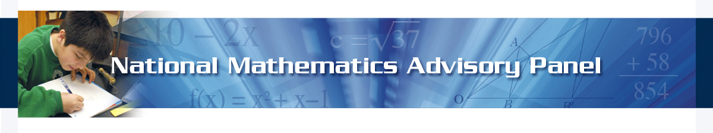
NATIONAL MATH PANEL FORUM
OCTOBER 6 & 7, 2008 - Marriott Wardman Park, WASHINGTON, DC

AGENDA
Monday, October 6
5:00-6:00 p.m. REGISTRATION – Thurgood Marshall Registration B

6:00-7:00 p.m. PLENARY SESSION – Thurgood Marshall Ballroom, SW

- Welcome, William McCallum
- National Math Panel Overview, Larry Faulkner
- Teachers Topic Area, Deborah L. Ball
- Question and Answer Session

7:00-8:00 p.m. RECEPTION – Thurgood Marshall Southwest Foyer

Tuesday, October 7
7:00-8:00 a.m. REGISTRATION – Thurgood Marshall Registration B

8:00-9:15 a.m. PLENARY SESSION – Thurgood Marshall Ballroom
- Future of Math Panel’s Findings and Recommendations, Ray Simon, Deputy Secretary of Education
- Research Topic Area, Joan Ferrini-Mundy
- Instructional Materials Topic Area, Robert Siegler
- Learning Processes Topic Area, A. Wade Boykin
- Question and Answer Session

9:15-9:30 a.m. BREAK

9:30-11:30 a.m. BREAK OUT SESSIONS (see packet for assignments)
- Introductions and Sharing of Team Goals
- Individual Team Time - Refine Action Plans

11:45-1:00 p.m. LUNCH – Thurgood Marshall Ballroom
- Keynote Remarks, Margaret Spellings, U.S. Secretary of Education
- Introduction to Doing What Works website National Math Panel Report-based Content, Jennifer Ballen Riccards
- Announcements

1:00-1:15 p.m. BREAK

1:15-2:30 p.m. BREAK OUT SESSIONS (Continuation of Morning Session)
- Individual Teams Report Out
- Finalizing Team Reports
- Prepare Slide for Forum Report Out

2:30-2:45 p.m. BREAK

2:45-4:00 p.m. PLENARY SESSION – Thurgood Marshall Ballroom
- Reports from the Break Out Groups
- Next Steps

Financial Support From:
ExxonMobil Foundation & National Science Foundation

NATIONAL MATH PANEL FORUM
OCTOBER 6 & 7, 2008 - Marriott Wardman Park, WASHINGTON, DC

PRESENTERS

OCTOBER 6

(In order of William McCallum, Chair of the Conference Board of Mathematical Sciences
appearance) (CBMS); University Distinguished Professor of Mathematics and Director of the Institute for Mathematics and Education at the University of Arizona

Larry Faulkner, Chair of the National Mathematics Advisory Panel; President of the Houston Endowment; President Emeritus of The University of Texas at Austin – Overview

Deborah L. Ball, Dean of the School of Education and William H. Payne Collegiate Professor at the University of Michigan; Member of the National Math Panel – Teachers Topic Area

OCTOBER 7

Morning Plenary: Ray Simon, Deputy Secretary of the U.S. Department of Education; Ex Officio
(In order of Member of the National Math Panel
appearance)
Joan Ferrini-Mundy, Division Director of Research on Learning in Formal and Informal Settings at the National Science Foundation; Ex Officio Member of the National Math Panel - Research Topic Area

Robert “Bob” Siegler, Teresa Heinz Professor of Cognitive Psychology at Carnegie Mellon University; Member of the National Math Panel - Instructional Materials Topic Area

A. Wade Boykin, Professor and Director of the Graduate Program in the Department of Psychology at Howard University; Member of the National Math Panel - Learning Processes Topic Area

Lunch: Margaret Spellings, Secretary, U.S. Department of Education

Jennifer Ballen Riccards, Doing What Works Website Manager, U.S. Department of Education

OTHER PANELISTS PRESENT

Francis “Skip” Fennell, Professor of Education, McDaniel College; Past President, National Council of Teachers of Mathematics

Hung-Hsi Wu, Professor of Mathematics, University of California at Berkeley

